Đề tài 166
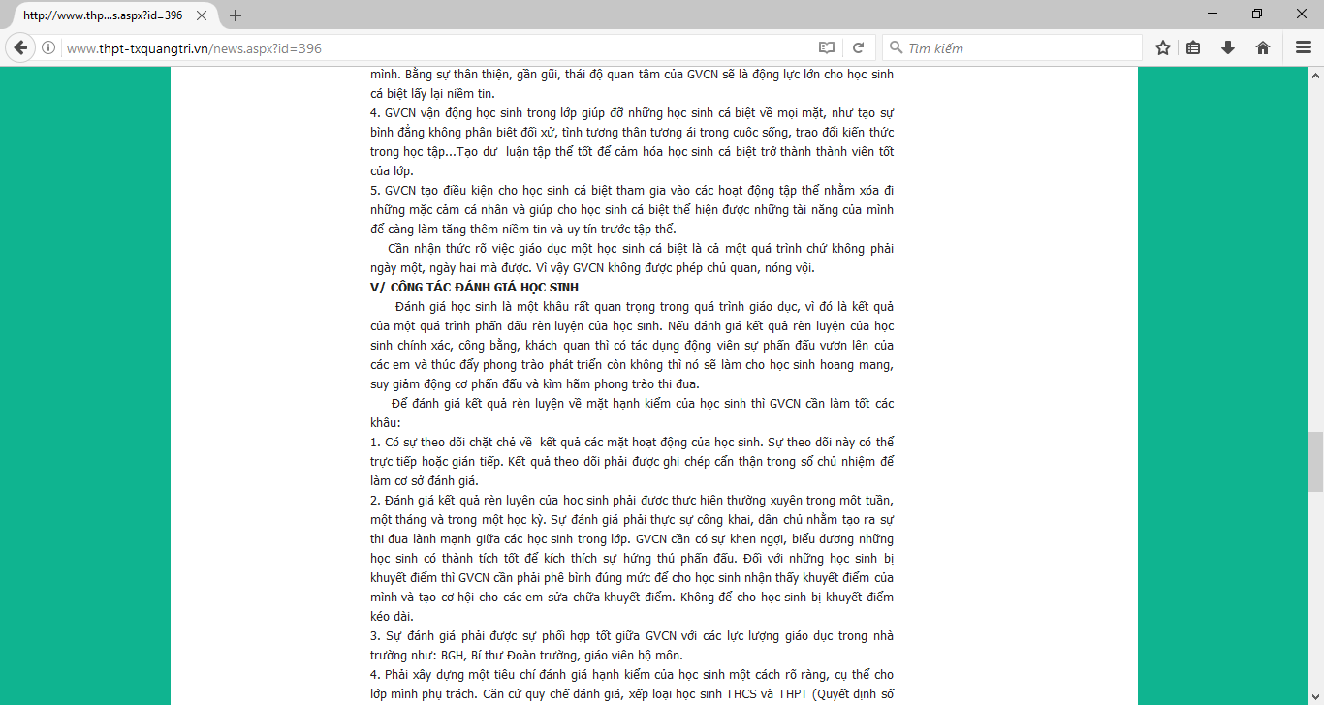

Đề tài 177
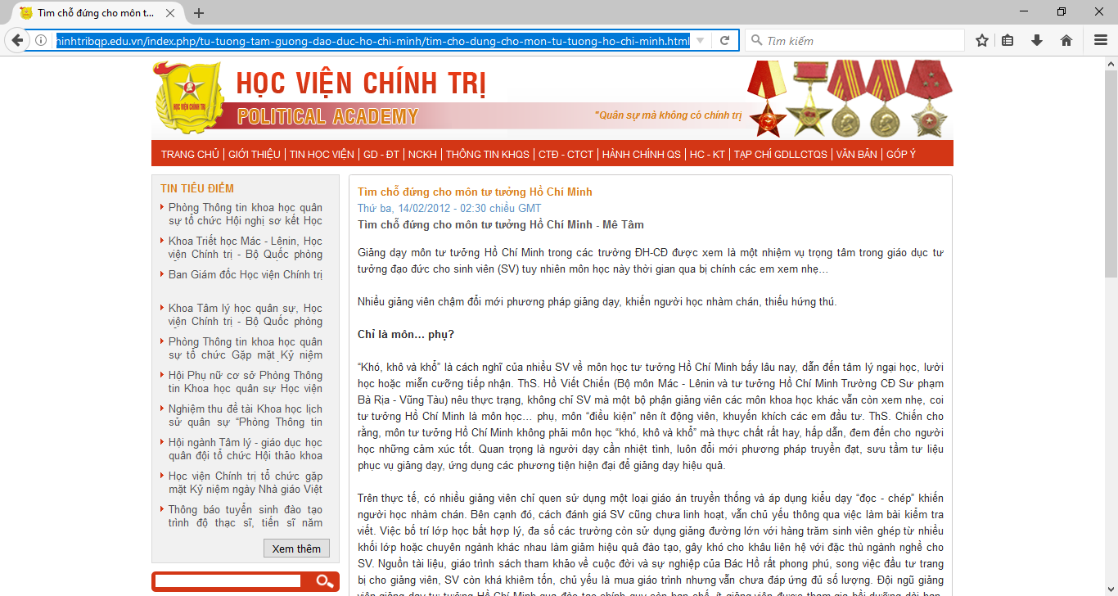
Đề tài 348
http://ntrai.camlam.edu.vn/index.php?language=vi&nv=tai-lieu-day-hoc&op=Ngien-cuu-KHSPUD-SKKN/CONG-TAC-CHU-NHIEM-LOP-7

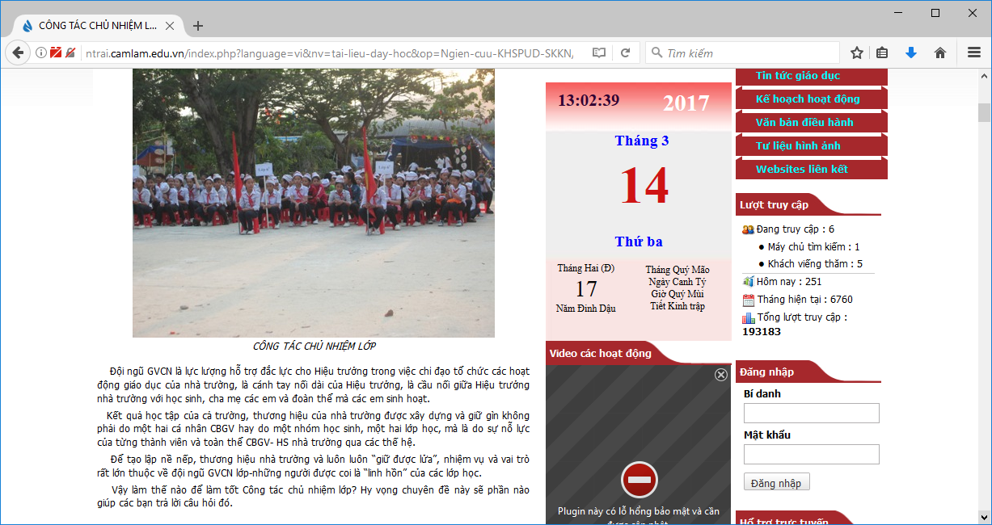
http://giaoducthoidai.vn/trao-doi/to-chat-de-lam-nen-giao-vien-chu-nhiem-tot-556078.html
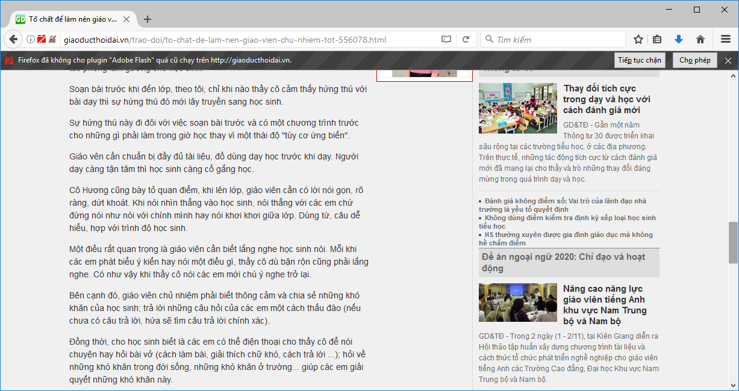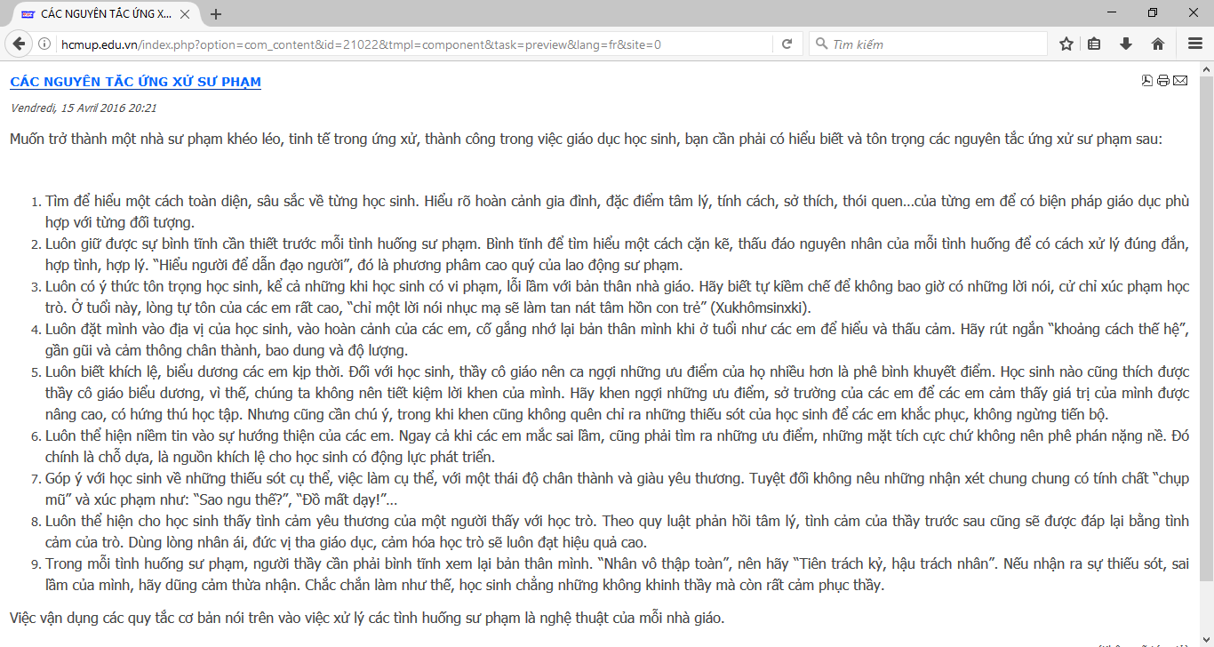
http://media.bacninhedu.vn/Data/bacninhedu/thptthuanthanh1/Attachments/10D2%20-Nguyen%20Thi%20Hoai%20GI%C3%81O%20VI%C3%8AN%20CH%E1%BB%A6%20NHI%E1%BB%86M%20V%E1%BB%9AI%20C%C3%94NG%20T%C3%81C%20GI%C3%81O%20D%E1%BB%A4C%20%C4%90%E1%BA%A0O%20%C4%90%E1%BB%A8C.pdf
Đề tài 207
http://hoidapit.com.vn/Questions/ViewQuestions/3507/mot-so-kinh-nghiem-de-ban-co-mot-phong-cach-lap-trinh-chuyen-nghiep.html
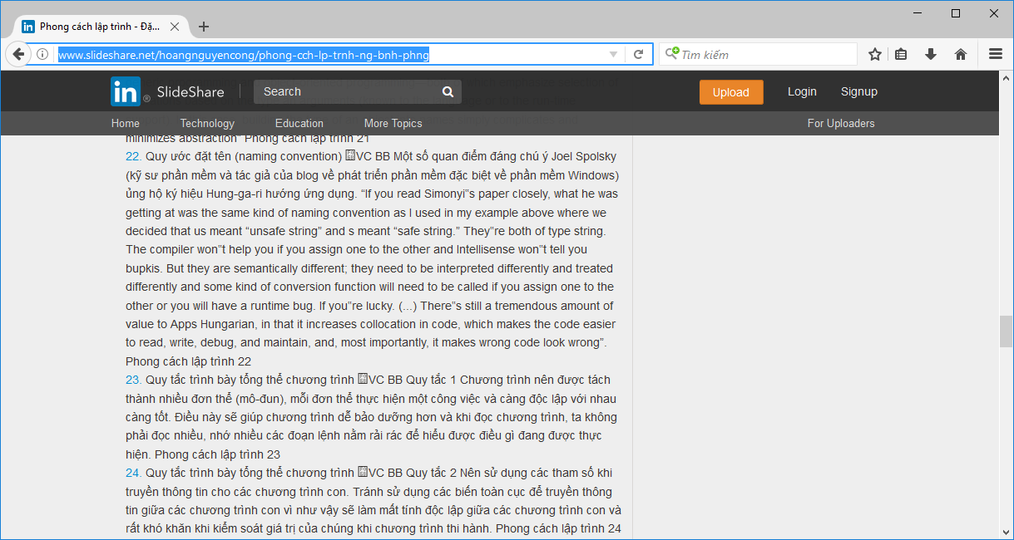
http://www.slideshare.net/hoangnguyencong/phong-cch-lp-trnh-ng-bnh-phng


